Bootstrap Examples

Modal Popup:

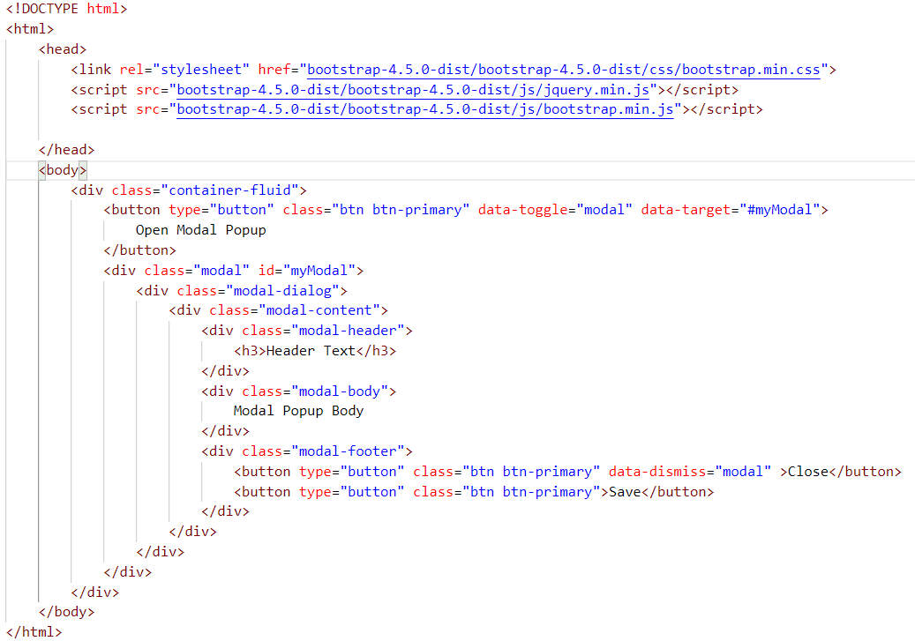

Bootstrap Icons:

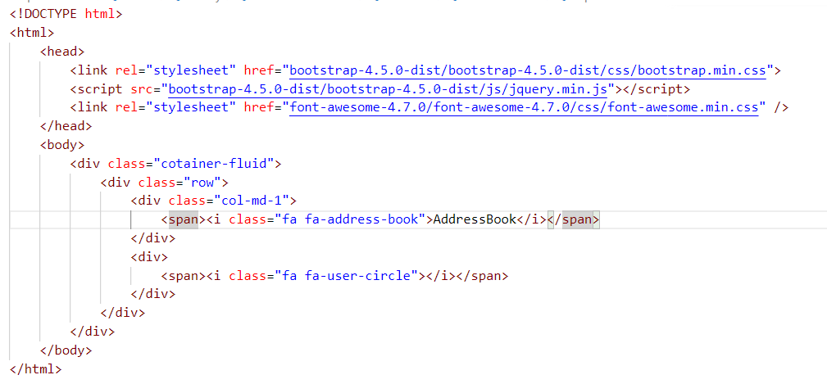

jQuery

1. You need some hands on experience on HTML,CSS and Javascript
2. jQuery is one of the most popular javascript frameworks
3. jQuery is very lightweight javascript framework
4. jQuery caption of “write less,do more”
5. jQuery is cross browser framework that can supports different kinds of browsers like chrome, firefox, safari and Internet explorer 9+
6. The extension of jquery file also .js only
7. Some of the popular companies using jQuery is Microsoft, IBM, Google

Let’s Get started with jQuery

1. jQuery has CDN(Content Delivery Networks)
2. jQuery as Local machine

**Download this jQuery**

Go to Website of jquery.com and Download the latest version and Make a copy of it save into current working directory

**How to include into HTML Doc**

<script></script> by using this tag we can import the jquery file into the html doc and you can also attribute called type=”text/javascript”

**First Example of jQuery**

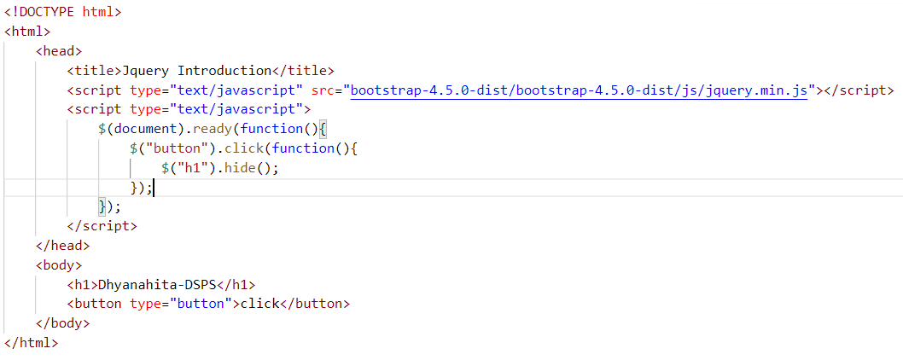

1. First method of jquery will be executed as document and ready function
2. And after that user defined function will be executed as like button click event

**jQuery Example based on ID format**

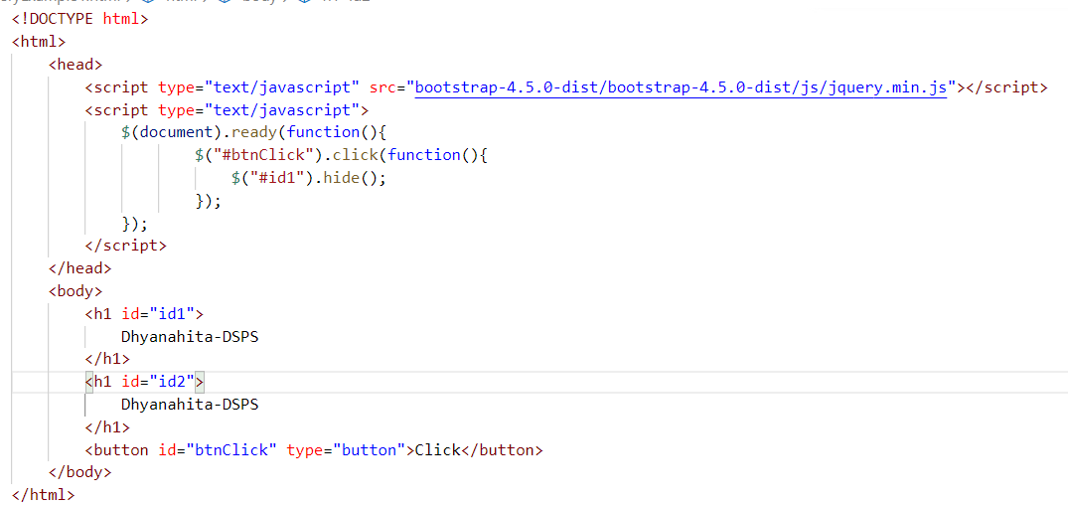

Task : Define a HTML Doc with the help of class format and include the Jquery in it

jQuery Methods

1. **hide()**
2. **show()**
3. **Toggle()**

**All of the above methods will have input parameter as time and time will be in milliseconds format**

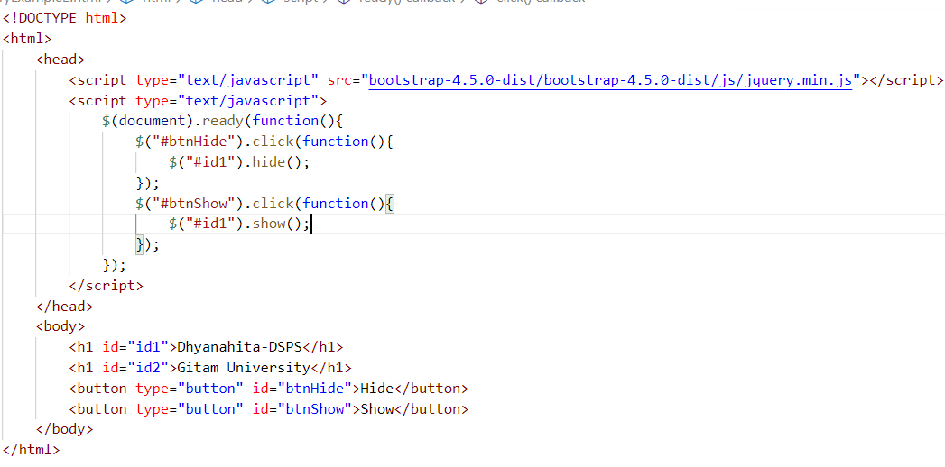

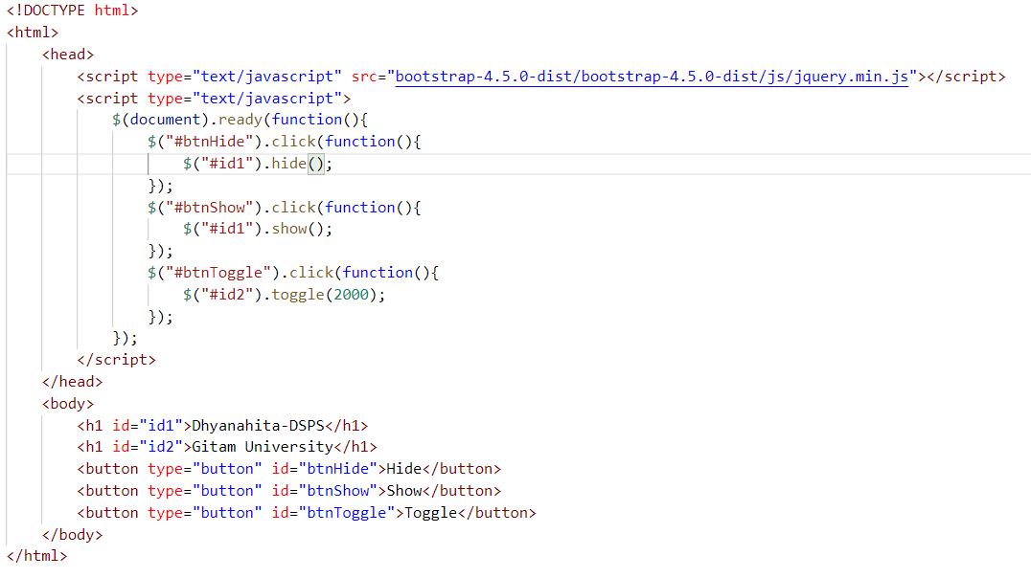

**fadeIn() fadeOut() and fadeToggle()**

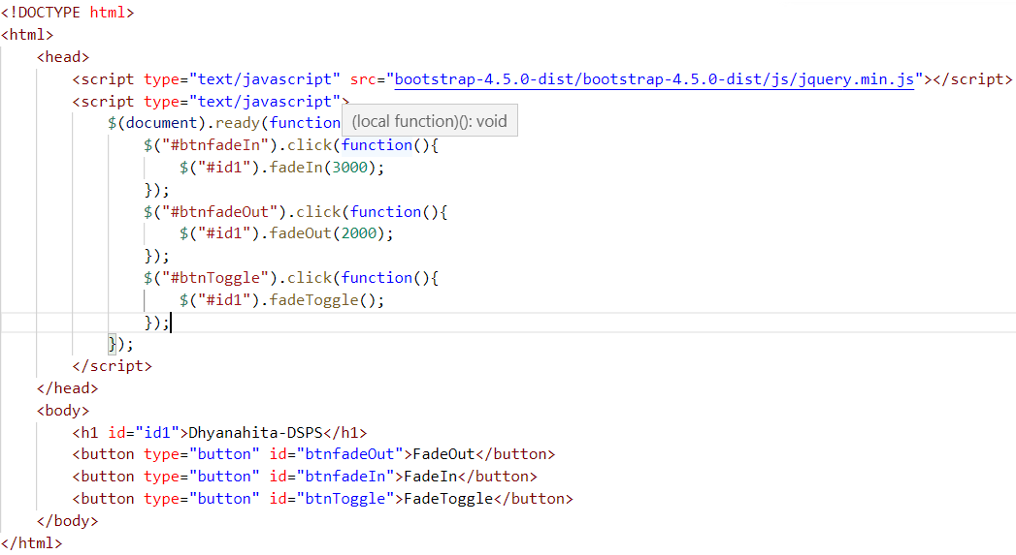

**slideUp(), slideDown() and slideToggle()**

